**Experiment No.: 3**

**Aim :** Familiarizing of Linux command

**CO2:**

Perform system administration task.

**Procedure**

1. **pwd** -: Displays the full path name of your current directory.

**Output**



1. **ls -:** To list files and contents.
2. **ls-R -:** It will display the content of the sub-directories also.
3. **ls-l -:** It will show the list in a long list format.
4. **ls-al -:** Detailed information about files and directory.
5. **ls-a -:** The (ls -a) command will enlist the whole list of the current directory including the hidden files.
6. **ls-t -:** Sort by time and date.

**Output**

**2.**



**a.**

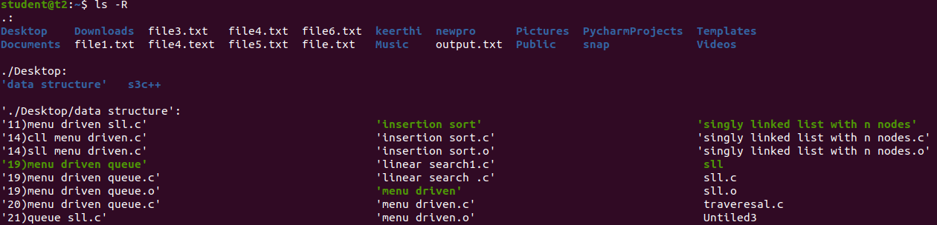

**b.**

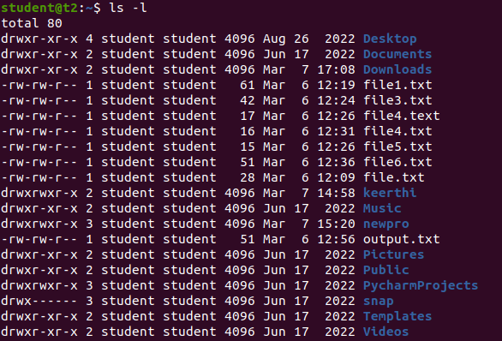

**c.**

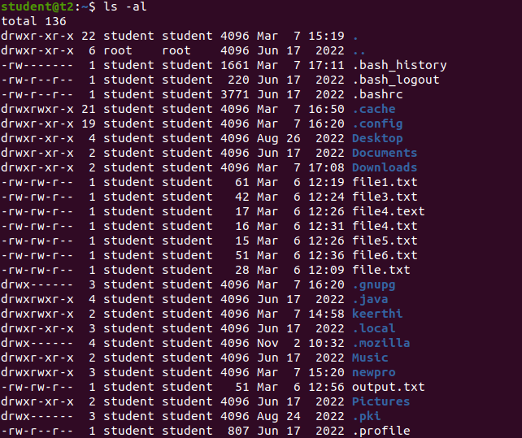

**d.**



**e.**



1. **mkdir -: mkdir** command in Linux allows the user to create directories

**Output**



1. **cd -:** Linux **cd** command is used to change the current working directory.

**Output**



1. **cd -- -:**To move to the previous directory.

**Output**



1. **history -:** To view the previously executed commands.

**Output**

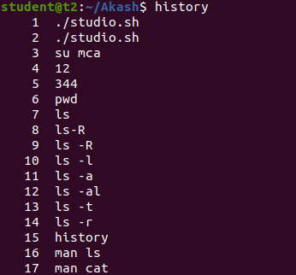

1. **man -:** man command in Linux is used to display the user manual of any command that we can run on the terminal.

**Output**

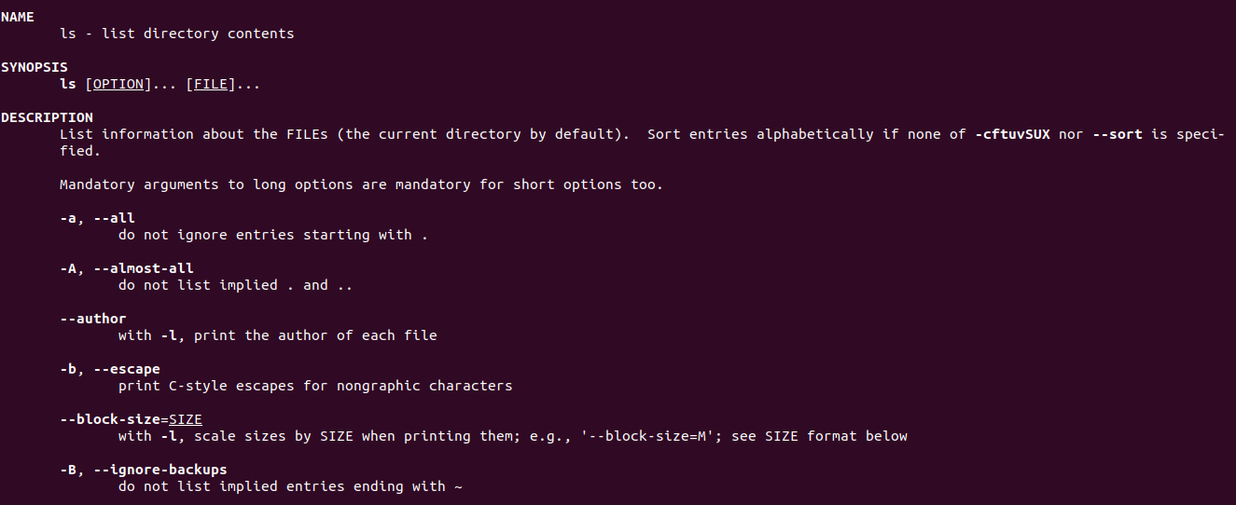

1. **cat>filename -:** Used to create a new file.

**Output**

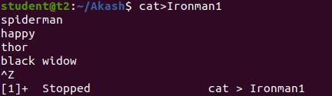

1. **cat -:** Used to display the content of file.

**Output**

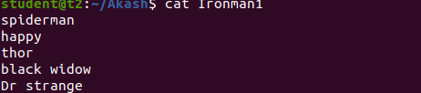

1. **cat>>filename -:**to append the content of file.

**Output**

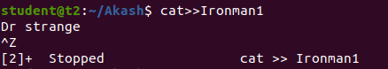



1. **cat -n filename** -: display the line number.

**Output**

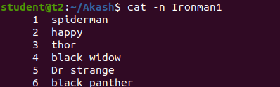

1. **cat -b -:** to remove the empty line.

**Output**

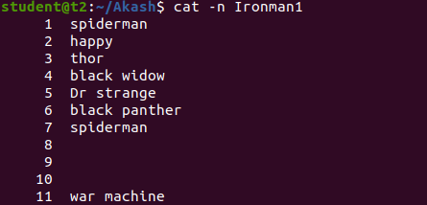

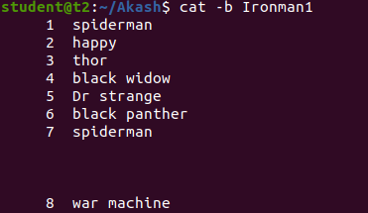

**Result**

The program was executed and the result was successfully obtained. Thus CO2 was obtained.